ICS 103: Computer Programming in C
Spring Semester 2011-2012 (Term-112)
Lab #4: Selection Statements
Objectives:
1. Learn to use if and switch statements:
- Two-way selection (if-else statement)
- One-way selection (if-statement)
- Multi-way selection with else option (if - else if – else)
- Multi-way selection with no else option (if – else if – else if)
- Nested if statements
- switch statement with default option
- switch statement with no default option
2. Learn to use functions of type void to display menu options

Two-way selection (if-else statement)
An if-else statement is used to execute a statement or a compound-statement when a condition is true; and another statement or compound-statement when that condition is false.
Single statements | Compound statements
if(condition)  statement1;  else  statement2; | if(condition)  compound_statement1  else  compound_statement2
Execute statement1 if condition is true else execute statement2 | Execute compound_statement1 if condition is true else execute compound_statement2  Note:  - It is a syntax error to put a semicolon after the closing brace of compound_statement1  - A compound statement may contain  zero or more statements
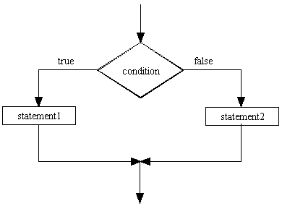 | 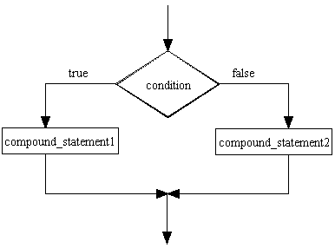
Example: Finding max of two numbers  if(x >= y)  max = x;  else  max = y; | Example:  scanf("%c", &currencyType);  if(currencyType = = 's' || currencyType = = 'S'){  printf("Enter positive amount ");  scanf("%lf", &amount);  riyalBalance = riyalBalance + amount;  }  else  printf("Wrong currency type");
One-way selection (if-statement)
Used to execute a statement or a compound_statement when a condition is true.

Single statements | Compound statements
if(condition)  statement1; | if(condition)  compound_statement1
Execute statement1 if condition is true | Execute compound_statement1 if condition is true
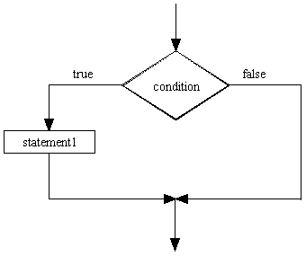 | 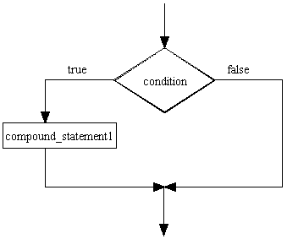
printf(“Enter a number: “);  scanf(“%lf”, &num);  if (num > 0)  printf(“The square root is %lf”, sqrt(num)); | printf(“Enter a number: “);  scanf(“%lf”, &num);  if (num > 0) {  printf(“The square root is %lf”, sqrt(num));  printf(“The natural logarithm is %lf”, log(num));  }
Example: Finding max of three numbers  max = num1;  if(num2 > max)  max = num2;  if(num3 > max)  max = num3; | Example:  scanf("%c", &currencyType);  if(currencyType == 's' || currencyType == 'S')  {  printf("Enter positive amount ");  scanf("%lf", &amount);  riyalBalance = riyalBalance + amount;  }

Multi-way selection with an else option (if- else if - else statement)
Used to execute the first statement or the first compound_statement whose corresponding condition is true. The statement in the else part is executed if each condition is false.
Single statements | Compound statements
if(condition1)  statement1;  else if(condition2)  statement2;  else if(condition3)  statement3;  .  .  .  else if(conditionM)  statementM;  else  statementN; | if(condition1)  compound_statement1  else if(condition2)  compound_statement2  else if(condition3)  compound_statement3  .  .  .  else if(conditionM)  compound_statementM  else  compound_StatementN
Note: There may be one or more else if branches | Note:  - There may be one or more else if branches.  - It is a syntax error to put a semicolon  after the closing brace of a compound statement in an if branch.
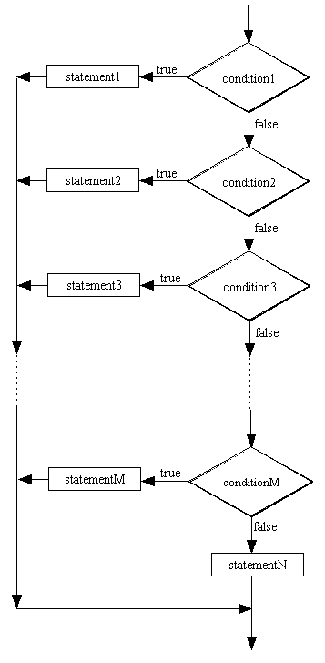 | 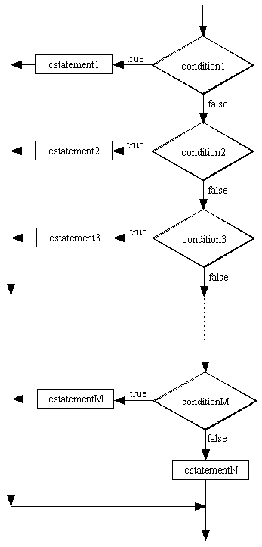
int validGrade = 1; // set validGrade to true
double grade;
printf("Enter grade");
scanf("%lf", &grade);
if(grade < 0.0 || grade > 100.0)
validGrade = 0; // set validGrade to false
else if(grade >= 85.0)
letterGrade = 'A';
else if(grade >= 75.0)
letterGrade = 'B';
else if(grade >= 65.0)
letterGrade = 'C';
else if(grade >= 45.0)
letterGrade = 'D';
else
letterGrade = 'F';

if(validGrade)
printf("The letter grade is %c", letterGrade);
else
printf("Error: Invalid grade");

Multi-way selection without an else option (if - else if - else if statement)

Used to execute the first statement or compound_statement whose corresponding condition is true. No if-branch is executed if each condition is false.

Single statements | Compound statements
if(condition1)  statement1;  else if(condition2)  statement2;  else if(condition3)  statement3;  .  .  .  else if(conditionM)  statementM;  else if(conditionN)  statementN; | if(condition1)  compound_statement1  else if(condition2)  compound_statement2  else if(condition3)  compound_statement3  .  .  .  else if(conditionM)  compound_statementM  else if(conditionN)  compound_StatementN
Note: There may be one or more else if branches | Note:  - There may be one or more else if branches.  - It is a syntax error to put a semicolon  after the closing brace of a compound statement in an if branch (except the last branch).
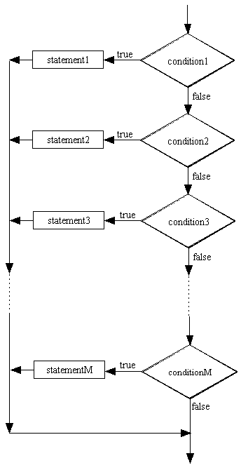 | 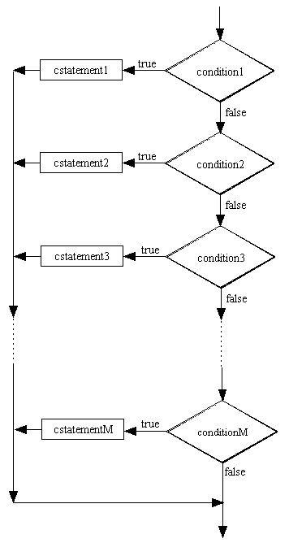
Example:

if(octaneNumber < 91)
printf("Do not use this gasoline");
else if(octaneNumber < 95)
printf("You may use this gasoline");

Nested if statements
The compound statement in an if-branch or an else-branch of an if-statement may contain one or more of any type of if-statement discussed above.

Example:

if(grade < 0.0 || grade > 100.0)
printf("Error: Invalid grade");
else{
if(grade >= 85.0)
letterGrade = 'A';
else if(grade >= 75.0)
letterGrade = 'B';
else if(grade >= 65.0)
letterGrade = 'C';
else if(grade >= 45.0)
letterGrade = 'D';
else
letterGrade = 'F';

printf("The letter grade is %c", letterGrade);
}

Nested if structures can be complicated:

if(condition1){  statement1;  if(condition2)  statement2;  else  statement3;  statement4;  }  else{  if(condition3)  compound_statementA  else if(condition4)  compound_statementB  else  compound_StatementC  compound_StatementD  } | 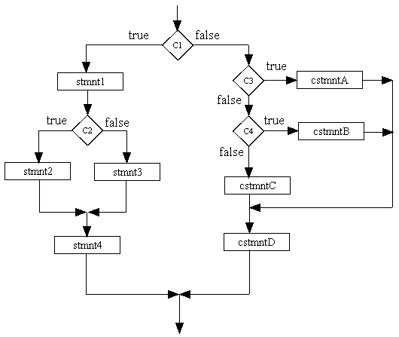

Note: In a nested if statement, the last else is associated with the closest unpaired if, unless braces are used to alter the default pairing:

Example:
if(hours < 9)
if(distance > 500)
printf("Type 01");
else
printf("Type 02");

is equivalent to:

if(hours < 9){
if(distance > 500)
printf("Type 01");
else
printf("Type 02");
}

Switch statement

The if- else if - else statement is used in programming situations where one set of statements must be selected from many possible alternatives. The switch statement provides an alternative to this statement for cases that compare the value of an int or char expression to a specific int or char constant.

The general form of the switch statement is:

switch(int or char expression){
case constant1: statementList1;
break;
case constant2: statementList2;
break;
.
.
.
case constantM: statementListM;
break;
default: statementListN;
}

Note:
- The case constants must be distinct int or char constants; otherwise there is a syntax error.
- A statementList may contain zero or more semi-colon separated statements. It is not necessary for statementList to be a compound-statement.
- The default label together with its statementList may be missing.
- The break statement following a statementList may be missing.
- The int or char expression is evaluated and then the statementList of the case value that equals to the expression is executed. If there is a break statement, control passes to the statement after the switch; otherwise, the following statementLists are executed until a break statement is encountered, control then passes to the statement after the switch statement.
- If expression is not equal to any case value, the statementList for the default label is executed, control then passes to the statement after the switch statement. If expression is not equal to any case value and there is no default label, control passes to the statement after the switch without executing any switch statementList.

switch example01: display the name of a digit:
int digit;
printf("Enter an integer digit:\n");
scanf("%d", &digit);
switch(digit){
case 0: printf("zero");
break;
case 1: printf("one");
break;
case 2: printf("two");
break;
case 3: printf("three");
break;
case 4: printf("four");
break;
case 5: printf("five");
break;
case 6: printf("six");
break;
case 7: printf("seven");
break;
case 8: printf("eight");
break;
case 9: printf("nine");
break;
default: printf("Error: Invalid digit");
}

switch example02: classify a character

char c1;
printf("Enter an English alphabet\n");
scanf("%c", &c1);
if(c1 >= 'a' && c1 <= 'z' || c1 >= 'A' && c1 <= 'Z'){
switch(c1){
case 'a':
case 'A':
case 'e':
case 'E':
case 'i':
case 'I':
case 'o':
case 'O':
case 'u':
case 'U': printf("You entered a vowel\n");
break;
default: printf("You entered a consonant\n");
}
}else
printf("You entered a non-English alphabet\n");

Task#1:
Rewrite the C program below using one-way selection if statements instead of
if-else if -else and if-else. Note: The program you write will be less efficient than the one below.

#include <stdio.h>
#include <stdlib.h>
int main(void){
int grade;
char letterGrade;

printf("Enter grade between 0 and 100: ");
scanf("%d", &grade);

if(grade < 0.0 || grade > 100.0)
printf("Error: Invalid grade\n");
else
{
if(grade >= 85.0)
letterGrade = 'A';
else if(grade >= 75.0)
letterGrade = 'B';
else if(grade >= 65.0)
letterGrade = 'C';
else if(grade >= 45.0)
letterGrade = 'D';
else
letterGrade = 'F';

printf("The letter grade is %c\n", letterGrade);
}

system("PAUSE");
return 0;
}
Task# 2:
Convert the program-fragment below to a complete C program that uses if-else if -else statement instead of the switch statement:

printf(“Enter the student letter grade (A, B, C, D, or F) : “);
scanf(“%c”, &grade);
switch (grade) {
case ‘A’:
case ‘a’:
case ‘B’:
case ‘b’: printf(“Good standing”);
break;
case ‘C’:
case ‘c’ printf(“O.K.”);
break;
case ‘D’:
case ‘d’:
case ‘F’:
case ‘f’: printf(“Poor, student is on probation”);
break;
default: printf(“Invalid letter grade”);
}
Task# 3:
Write a program that prompts and reads two integer numbers. It then checks the numbers and prints one of the following messages accordingly:

You have entered two even numbers.
You have entered two odd numbers.
You have entered one even number and one odd number.

Hint: Use the modulus operator (%) for checking the numbers.

Task#4:
Write a C program that displays the following menu:
1. Find area and perimeter of a square
2. Find area and perimeter of a rectangle
3. Find area and perimeter of a circle
The menu will be displayed using a user defined function called menu()
The program then reads the menu choice and behaves as in the following table:

Menu choice | Program behavior
Input other than 1, 2, 3 | The program displays the following error message :  Error: Wrong menu choice
1 | The program prompts for and reads the length of a square. It then computes and displays the area and the perimeter of the square.
2 | The program prompts for and reads the length and the width of a rectangle. It then computes and displays the area and the perimeter of the rectangle.
3 | The program prompts for and reads the radius of a circle. It then computes and displays the area and the perimeter of the circle. Your program must use a named constant PI that has a value of 3.1429

Note: Assume that the values read by the program for options 1, 2, and 3 are in centimeters. For these options, your program must display appropriate units in the output.

